**Math Dog Game**

**About this app:**

Teachers have innovatively crafted specialized learning tips for young math enthusiasts, blending fun through mixed math games while tailoring the experience to each child’s level of understanding.

**Platforms**:

Android, iOS

**Features**:

Generate questions, confirm the correctness of answers, and provide appropriate responses, including animations, sounds, etc., based on the answers.

**More information:**

**Source code**: https://github.com/ytphi/CSUSB-CSE6550-math4kid-team2

**Author**: Liu, Yutong

**Software used:**

Unity: The evolution of Unity, a licensed game engine utilized for creating video games and various applications, has transformed Unity Technologies into the prominent organization it is today.

**Platforms**:

Android, iOS

**Features**:

3D and 2D graphics support

East to understand architecture

Unity scripting API

Animation Tools

**More information:**

**Source code :** https://unity.com/download

**Author:** Kowser, Sultana

**Visual Studio**:

A Microsoft IDE empowers developers to create apps for desktops, web, mobile, and more.

**Platforms**:

Android, iOS.

**Features**:

Develop

Debug

Test

Collaborate

Extend

**More information:**

**Source code :** [<https://code.visualstudio.com/download>](https://code.visualstudio.com/download)

**Author:**

**Math Kids App Screens:**

**First Screen**:

Home screen displays the game page, and by clicking on the play now button, it directs into the game

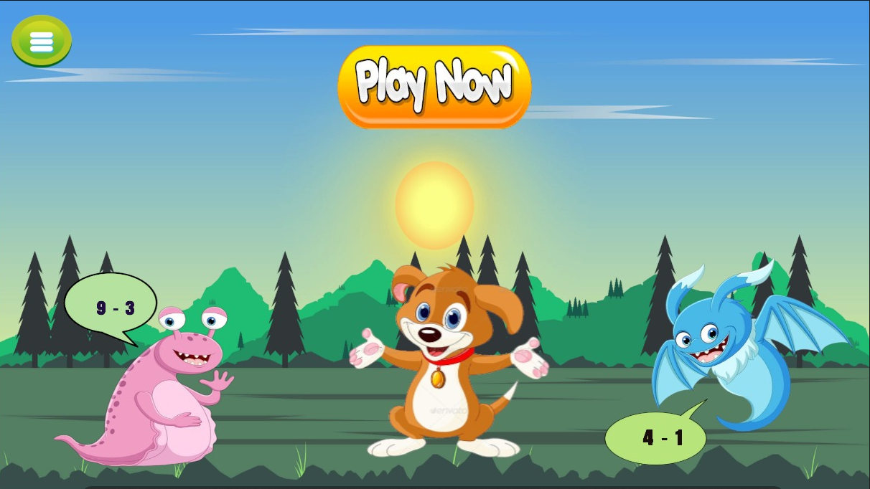

**Author:** Kowser, Sultana

**Second Screen**:

By clicking the correct option in the subtracting puzzle, the game moves forward and displays the next question

And, for every correct answer the credit points will be increased

if the answer is wrong it shows try again and redirects back to the question

**Author:** Jella Sharanya

**Third Screen**:

If all the five questions are correct, then the screen displays the congratulations page.

**Author:** Jakkiredy Mohan Kumar Reddy

**Platforms**:

Android, iOS.

**Features**:

Screens

Questions

Options

Animations

**More information :**

**Source code** :

**Animated Transitions:**

**Platforms**:

Android, iOS.

**Features**:

Questions

Animations

**More information:**

**Source code**:

**Author**:

**Gaming Store:**

Commercial establishment specializing in selling video games, consoles, peripherals, and related merchandise for gaming enthusiasts.6y

**Author**:

**Technical Requirements:**

Software engineering tools : Azure DevOps (Boards, Pipeline, Repos, Test Plans, Artifacts)

User interface (UI) programming language : Unity

Programming language : C#

App front-end technology: Unity

App back-end technology : Azure App Service

Integrated development environment (IDE): Visual Studio for Unity

Software engineering team: Agile team

Google AdMob in-app ads

Nuget Packages

Cloud PaaS: Azure App Service

**Game Algorithm:**

Start

Install the game in the Android/IOS

As the start of the game, a math kid game screen immediately appears

Home screen displays the game page with play button, which helps to enter the game.

After entering the game subtracting question will be displayed on the screen

For every correct answer the next question will be displayed on the screen

For each correct answer the dog throws an apple to the monster and the monster will be disappeared

If we didn’t give any option, then the monster will come near the dog and the game will be ended

And it displays the ‘Try Again’ page, it contains replay button, home button and menu button

If we give all the answers correctly then the congratulations screen will appear and the game ends

End

**Platforms**:

Android, iOS

**Features**:

A fun filled educational app for kids to learn

Allows kids to learn subtraction in mathematics

For every correct answer by kid, they earn the reward points

It helps to learn subtraction.

**More information:**

**Source code:**

**Author:**

**UML Diagrams:**

Graphic representation of system structure, behavior, and relationships using standardized symbols

**Platforms**:

Android, iOS.

**Features**:

Abstraction

Standardized Notation

Various diagram types

Analysis and design

**More information :**

**Source code :** https://github.com/ytphi/CSUSB-CSE6550-math4kid-team2/blob/main/Documents/UML%20sequence.jpg

**Author :** Jakkampudi Sujana

**SRS:**

Software Requirements Specification (SRS) is a detailed document defining software project requirements, functions, and constraints.

**Platforms**:

Android, iOS.

**Features**:

Game objectives and mechanics

Levels and progression

Math topics

Scoring and feedback

Sound and visuals

**More information:**

**Source code**:

**Author:** Haridasula Rohith